DIABETES FLOW CHART |  | [current photo here]
[full name] Age: [age]
Grade: [grade or class]
When to do Blood Sugar Level (BSL) testing
- Prior to recess/snack
- Prior to & After physical activity/sport - this includes swimming
- If [name] indicates that [he/she] ‘feels low’
- 15 minutes After treatment for a Low BSL
- At 12:30pm, in the Health Centre, prior to [his/her] insulin injection
(after insulin, [name] is to return immediately for lunch with [his/her] class)
FLOW CHART FOR BSL ACTION
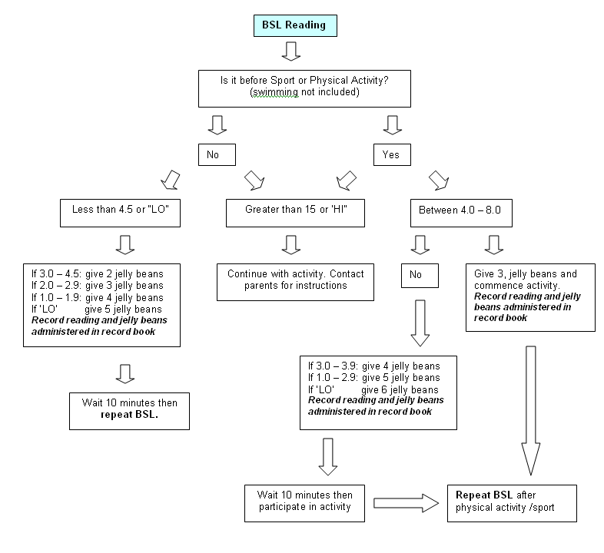
Management notes
[name]’s back pack must accompany [name] at all times
The Jelly Beans administered must only be from [his/her] supply in the backpack
Treatment of [his/her] BSL levels should be on the spot – do not send [his/her] to the Health Centre
All BSL readings and management must be recorded in the record book kept in [his/her] backpack
[name] has a mobile phone in [his/her] backpack – press black middle key, then * to unlock
For any emergency management do not leave [name] alone – adult supervision is required at all times.
If the Health Centre is not available then call [initials of nurses or staff].
Contacts
Mum: [contact details] | Dad: [contact details]
Health Centre: [contact details] | [initials of nurses or staff and their extensions]

