DIABETES ACTION PLAN  [full name] Age: [age] Grade: [grade]  [first]’s diabetic profile is managed using Manage BGL  BGLs, Carbs and Insulin must all be entered into the program  http://www.managebgl.com/ez/[share code]  Advantages of ManageBGL  - Immediate information and advice about [first]’s diabetic status  Insert  photo here  - Predictability of Low and High Blood Glucose Levels (BGLs)  - Continual shared knowledge between parents and staff |  |  |  |  | MANAGEMENT FOR WHEN WIZARD IS NOT ACCESSIBLE  Record all readings and actions in record book  Do not send [first] to the Health Centre – treat on the spot
In case of Low Blood Sugar Level BGL < 4.5 or the reading “LO”
Do this…
If 3.0 – 4.5 | Give 2 jelly beans
If 2.0 – 2.9 | Give 3 jelly beans
If 1.0 – 1.9 | Give 4 jelly beans
If “LO” | Give 5 jelly beans

If BGL Low before Physical Activity or Sport
Do this…
If 4.0 – 8.0 | Give 3 jelly beans and continue with activity
If 3.0 – 3.9 | Give 4 jelly beans  Wait 10 mins then join activity
If 1.0 – 2.9 | Give 5 jelly beans  Wait 10 mins then join activity
If “LO” | Give 6 jelly beans  Wait 10 mins then join activity
REPEAT BGL AFTER SPORT

WHEN TO TEST Blood Glucose Level (BGL)
The Wizard will provide the necessary instructions to manage BGL reading once taken
Prior to & After physical activity/sport - this does not include swimming  If [first] indicates that they ‘feel low’  After treatment for a Low BGL  Prior to fruit snack/ recess | Click Add BGL on Home Page  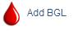 |  | 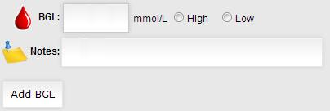
In case of High BGL - BGL >15 or the reading “HI”
Do this…
- May continue with normal activity
- If BGL above 15 contact parents for instructions
IMPORTANT  After entering BGL if fruit snack, recess or afternoon snack Carbs must be entered | Click Add Carbs on Home Page  Select type from drop down list |  | 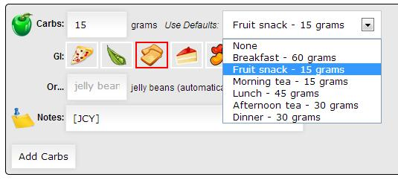
MANAGMENT NOTES
[first]’s back pack must accompany them at all times
The Jelly Beans administered must only be from her supply in the backpack
[mobile phone and how to use e.g. how to unlock]
For any emergency management do not leave [first] alone – adult supervision is required at all times.
If the Health Centre is not available then call [teacher or nurse initials]
LUNCH TIME MANAGEMENT
Prior to lunch [first] to attend the Health Centre for a BGL check and insulin injection.
Use the Wizard to record BGL and Carbs and calculate the insulin dose
Select Wizard from screen  Record BGL  If appropriate select Carbs  Press Calculate |  | 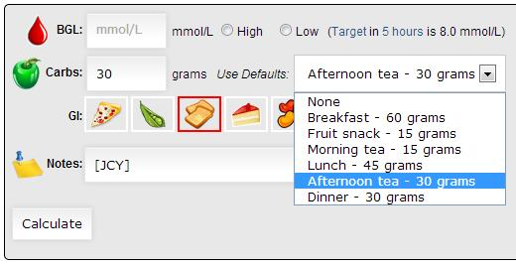 |  | The insulin dose to be delivered will be displayed.  This can be rounded up or down | CONTACTS  Health Centre [numbers]  Mum [numbers]  Dad [numbers]  [Teacher/Nurse Initials and Extension numbers]

